Scarecrow Row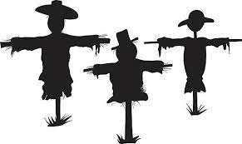
Allegany New York
Sponsored by Enchanted Mountain Garden Club

2021 Participation/Registration Form

________________________________ _______________
Contact Name Telephone
_______________________________________________________________
Family Name/Business
_______________________________________________________________
Address
_______________________________________________________________
City/State/Zip
_______________________________________________________________
Name of Scarecrow
_______________________________________________________________
Email
Please mail or email your Participation Form to:
Mary Linda Williams
3674 Geiger Hollow Road
Allegany, New York 14706
Email: mlw2142@gmail.com or call Mary Linda at 716-378-8001 Early registration is requested for wooden forms & limited scarecrow clothes that will be given to registered families only. ( see Pinterest for ideas for dressing your scarecrow) Scarecrows will be tied to lampposts on Main St. in Allegany starting September 27th.

